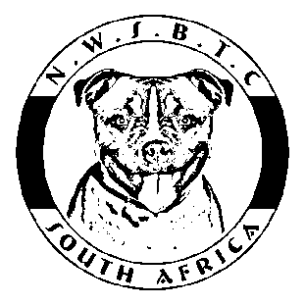The North West Staffordshire Bull Terrier Club in collaboration with Inquaba Biotechnical Industries (Pty) Ltd. is inviting you to join us for a workshop on
“Canine Colour Genetics 101”
presented by
Mischa Fraser, Msc Biotechnology, Inquaba Biotechnical Industries (Pty) Ltd.
Where: Goldfields Showground, Small Hall opposite
the restrooms.
When: 12th of August 2017, after the show approx.
14h30 – 16h00.
Cost: R40 per person. Please book by 31/7/2017 in order for us to have enough course material available.
- If you would like Ms Fraser to address a specific topic during the Q & A Session please e-mail your questions to nwsbtc@gmail.com before 31 July 2017.
- Enquiries/ bookings to be made via e-mail at nwsbtc@gmail.com, or via phone to Stefanie Pretorius at 063 274 6991.
Payments can be made by EFT with your surname and CCG101 as ref to:
North West Staffordshire Bull Terrier Club ABSA Centurion Branch Code 632 005
Account Number 405 594 4174 - please confirm your booking and payment via e-mail.
- Please bring along a pen and some paper to take notes on. The course notes will be made available after the seminar.
The course will cover the following:
- Some background on Inquaba Biotec and how they can help breeders.
- What is genetics?
- What is colour?
- How is colour formed in the skin and coat?
- What mutations can cause and case studies.
- Practical Scenarios and case studies.
- Small workshop in predicting the colours of a dog
- Questions and Answers session
Presented under the auspices of the NAPC and the Judges Sub-Committee.

